Web Privacy Project Section 2
Chrome Extension: Tracker Blocker and Fingerprint Protection

Chrome Extension Implementation
Overview
For this Web Privacy project, I implemented a Chrome extension called "Kitty Guard" that enhances user privacy by blocking trackers and preventing browser fingerprinting.

Tracker Blocking
I implemented tracker blocking using Chrome's declarativeNetRequest API to accommodate for Manifest v3. This way it basically blocks the trackers before they’re initaited. The extension uses a predefined blocklist of common tracking domains which are stored in the background script of the project repository. When a request matches a domain in this list, it's blocked before the browser can load it.
The implementation includes:
- A comprehensive list of common tracking domains (Google Analytics, Facebook, DoubleClick, etc.)
- Rules defined in rules.json that match requests to these domains
- Real-time counting of blocked trackers per page
- Storage of blocked tracker information for visualization purposes
Users can toggle switch on/off tracker blocking whenever needed so that it’s not mandatory when the extension is enabled.

Fingerprint Protection
For fingerprinting protection, I focused on Canvas fingerprinting since that is something we worked heavily in our class labs. To summarize, this fingerprinting is a technique websites use to uniquely identify browsers. My implementation:
- Uses a background script to inject protection code into the main page context using chrome.scripting (due to content script sandboxing limitations)
- Overrides Canvas API methods (HTMLCanvasElement.prototype.toDataURL and CanvasRenderingContext2D.prototype.getImageData)
- Adds subtle random noise to any canvas data before it's accessed, which prevents consistent fingerprinting as it alters the canvas output each time.
- Detects canvas fingerprinting specifically (since the project description only requested for one fingerprinting API) from the website and sends reports to the background script
- Displays alerts to the user when fingerprinting is detected on a site
Users can toggle switch on/off fingerprint protection mode whenever needed so that it’s not mandatory when the extension is enabled.

Additional Feature: Visualization
I added a visualization feature that shows users which tracking domains are most prevalent in their browsing. This includes:
- A counter showing the total number of trackers blocked on the current page
- A list view showing the most recently blocked trackers
- A bar chart visualization showing the top tracking domains and how many of their trackers have been blocked. This is done by grouping detected tracker URLs by domain.
The visualization helps users understand which companies are tracking them the most, providing transparency about web tracking practices.
Tracker Blocking Testing:
I visited 5 websites which have a lot of tracking, this includes:
- MSN: https://www.msn.com/en-ae?AR=3
- CNN: https://edition.cnn.com/
- NY Daily News: https://www.nydailynews.com/
- TheChive: https://thechive.com/
- HGTV: https://www.hgtv.com/

This testing was done where I opened the website with DevTools open to let all the requests come through. I also enabled my extension and kept it open alongside.
On the DevTools I filtered for Blocked Requests and I waited for about 30 seconds to let all the blocked requests come through on both my extension and the DevTools.

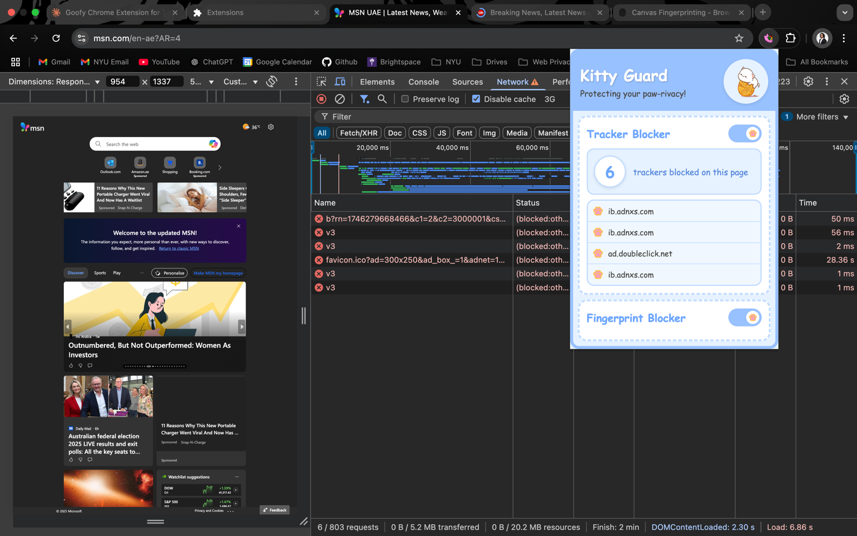
MSN:

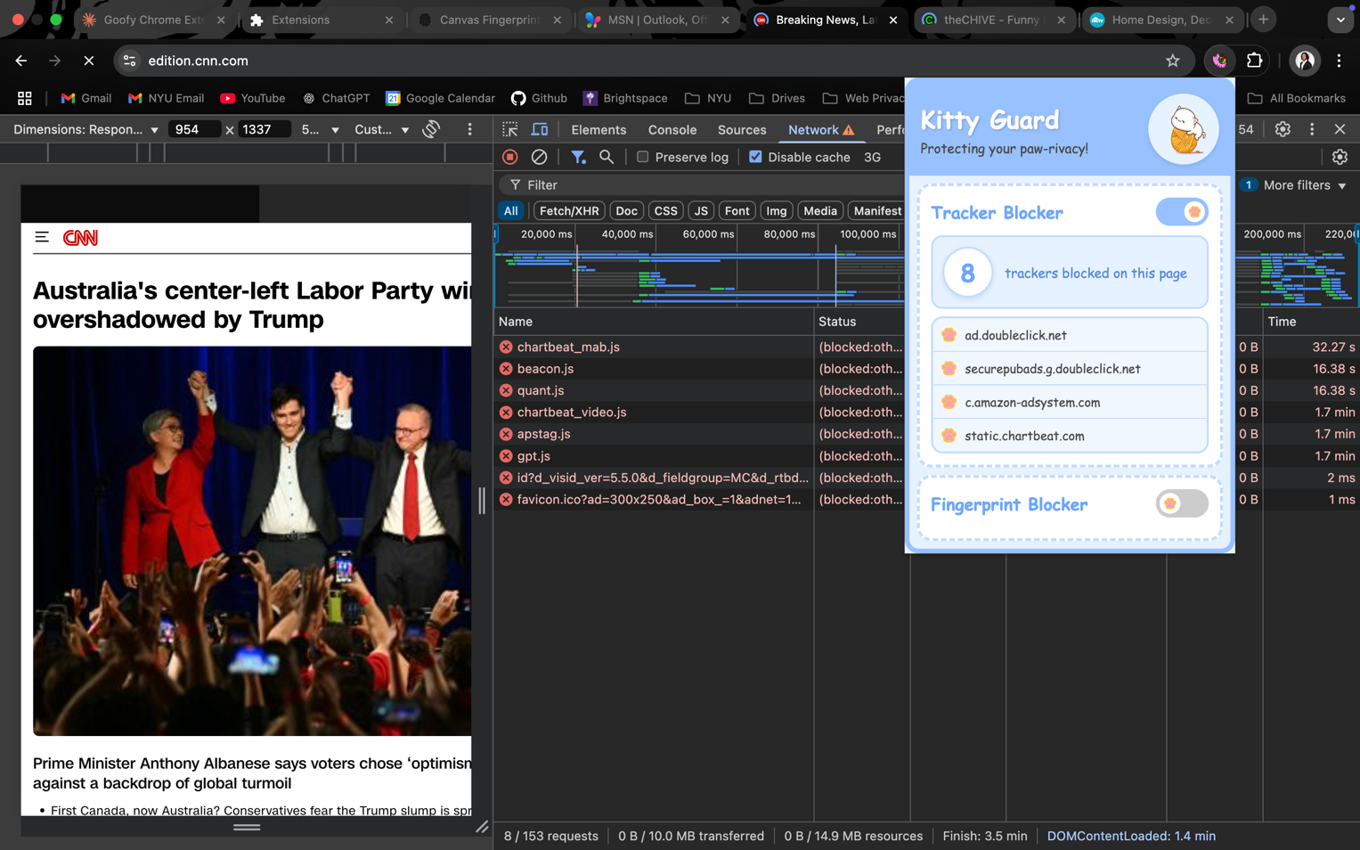
CNN:

NY Daily News:
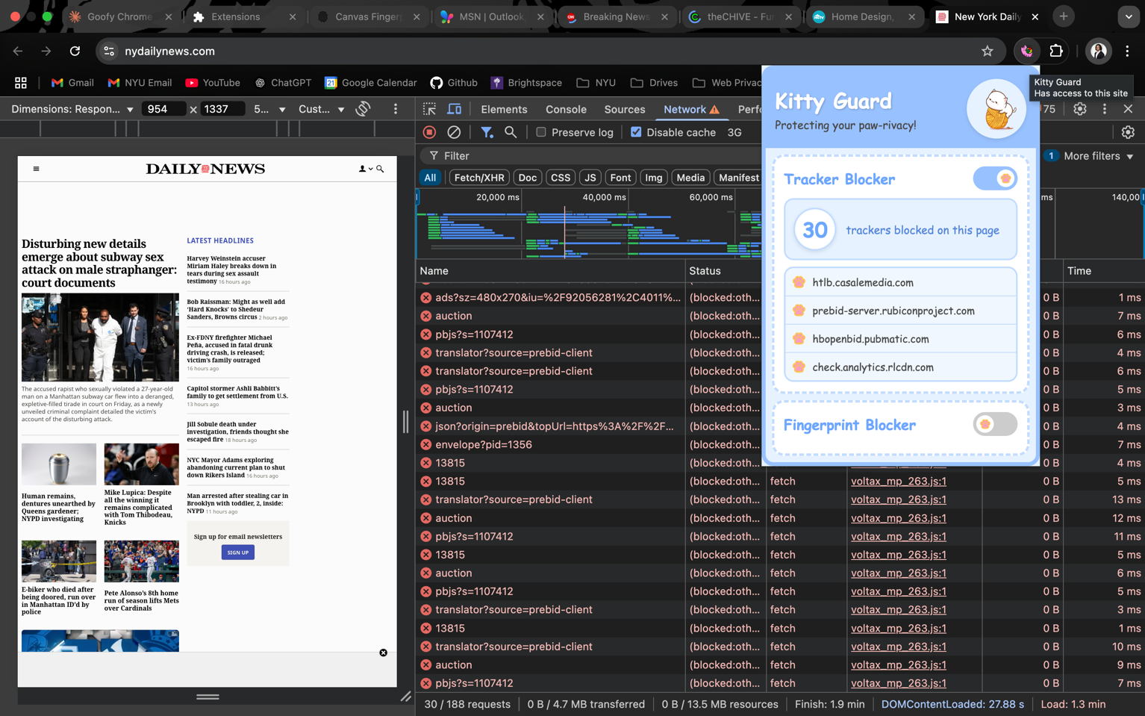

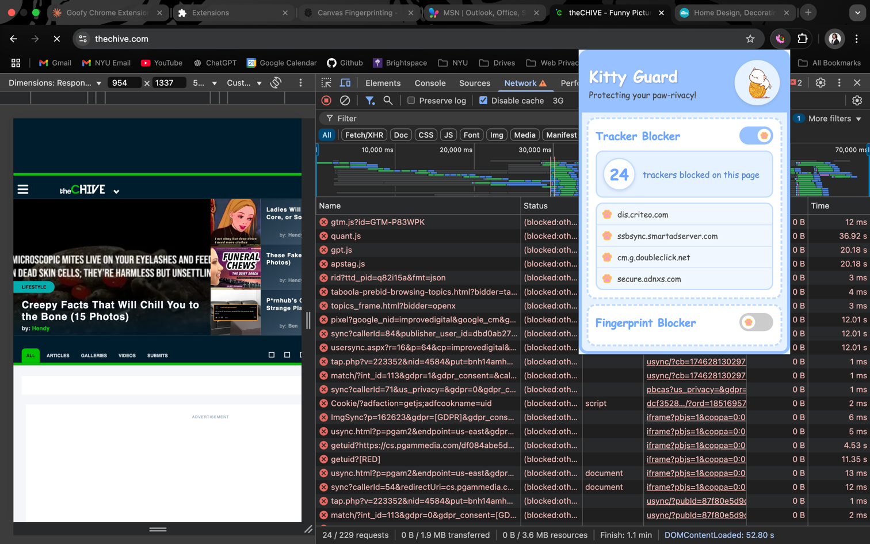
TheChive:

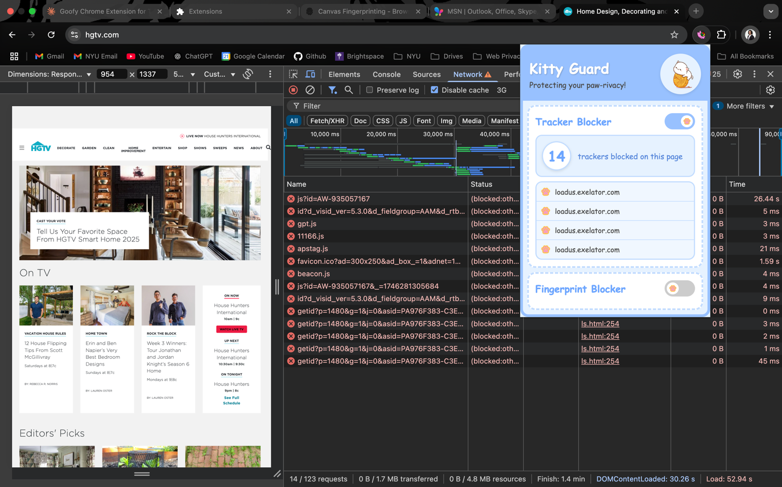
HGTV:

You can see for these websites; the extension is indeed working and it is blocking the trackers. For instance, you can notice in the DevTools that some blocked requests names are like ‘gtm.js’ which stand for Google Tag Manager and the extension picks those up and displays it on the list.
As an extra note, I noticed that with the DevTools open it takes a long time for the requests to come through. Therefore, it shows very few blocked requests/blocked trackers because very few come in within that 30 second span. However, if you were to load the website normally without the DevTools, the number of trackers blocked increases drastically. Here is an example of going to the same MSN website with only my extension enabled:
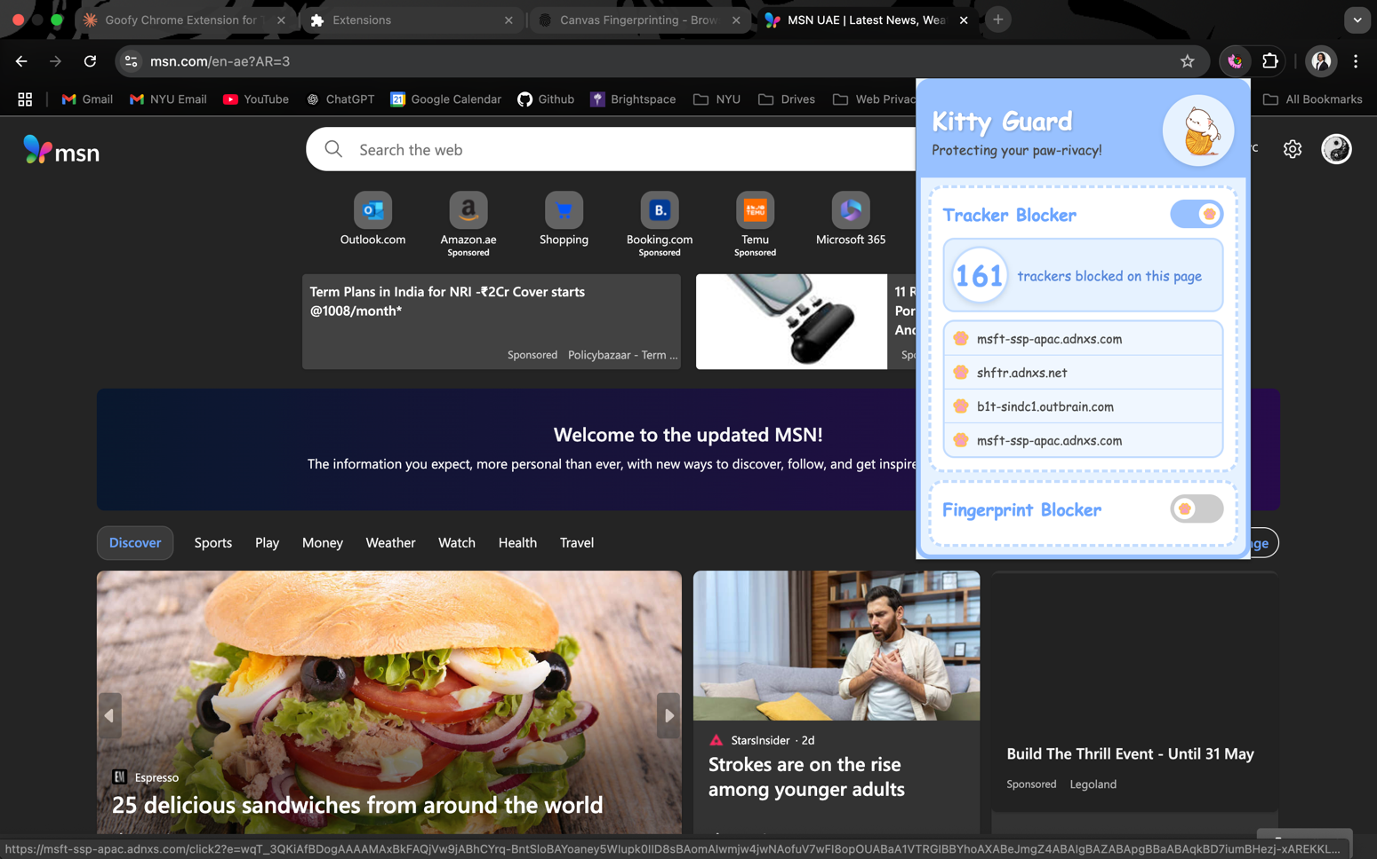

Fingerprint Protection Testing
To check if the fingerprint protection in my extension works, I used a simple test page (test.html) which is also in my project directory. This page draws the same thing on a canvas multiple times and checks if the output (the fingerprint) changes depending on which setting it is on.
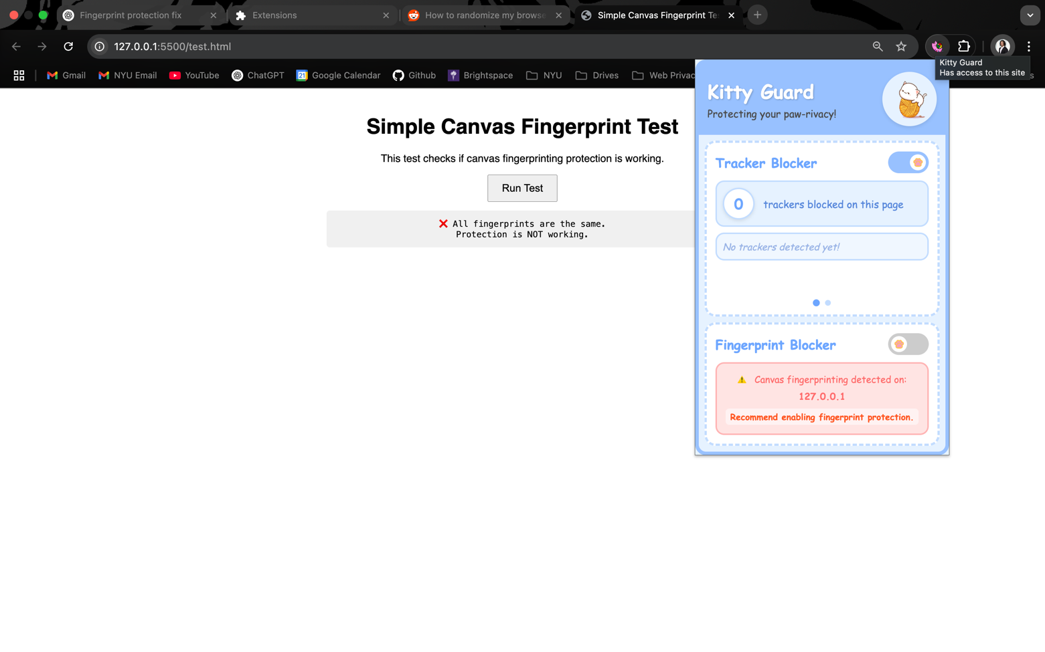
In the first test, I essentially disabled the fingerprint protection mode. As we can see from the screenshot, all the fingerprints were exactly the same each time, which is expected because nothing was interfering with the canvas.
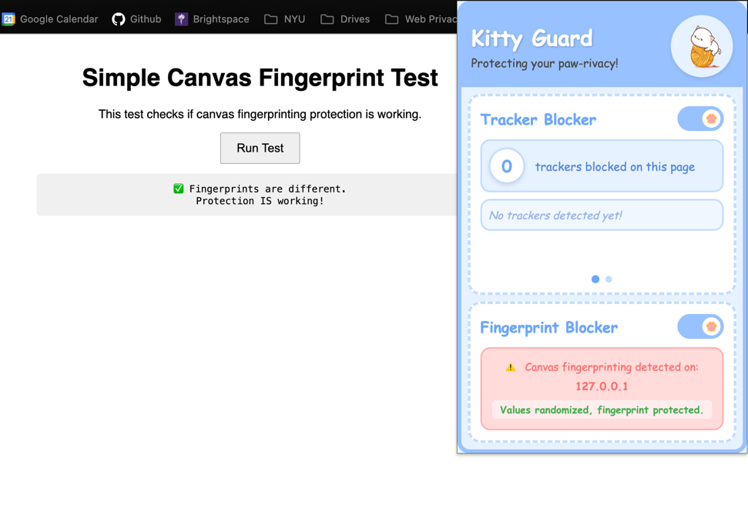

For the second test, I turned on fingerprint protection in the extension and ran the same test again. This time, the fingerprints were different each time, which means the extension successfully added noise to the canvas and protected the fingerprint.

An additional note with this is that you need to refresh the page after turning the protection on or off for it to take effect. This is because the script that modifies the canvas behavior is only injected when a page loads — it can’t be applied dynamically to an already loaded page.
Furthermore, we can see that in my test.html I have added Canvas Fingerprinting and the extension was able to detect that. You can also see this in live with other websites such as msn, cnn and others (more screenshots of this later in the report).
Additional Feature (Tracking Visualizations):
For my additional feature, I’ve added tracking visualization in two ways. One way is that you can see the list of all the recent trackers that get blocked when you visit a page (left side). These are the specific trackers.
I have also added a visualization to show the number of trackers blocked per each overall domain. This is an interesting visualization as you can then see which companies or entities tend to place their trackers most on certain websites. I should say that this shows the top 4 and it doesn’t fully equate the total number of trackers blocked as there are some which aren’t shown on the chart as it only shows the top 4. On top of that it only shows top domains which are from the blocking list only.
